**Format for Research Report ( 3-4 pages)**

Cover page : (Include the following information) See sample page image

* Project title
* College Logo
* Student Name and Register Number
* Supervisor/ Research guide details – Name, Designation & Organisation
* Program Details
* Semester
* Official address with e mail id & Contact Number

Introduction (in Brief)

Problem Definition / Research Objectives

Scope of research work

Methodology / Work Plan

Key findings

References

**Imparting Awareness On Mindful Eating Among Obese Adolescents (11- 14 Years)**

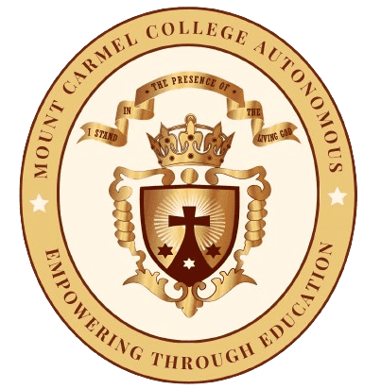

*Submitted by*

**SAYEDA AMINA HERMEIN NAZEER**

**Master of Science in Food Science and Nutrition**

Reg. No. M18FN22 – IV Semester

**2019- 2020**

**Mount Carmel College, Autonomous,**

**#58, Palace Road, Bengaluru -560052**

**(Affiliated to Bengaluru Central University)**

**2019- 2020**

***Research Guide Details***

**Dr. V. Padma,**

Associate Professor,

Department of Nutrition and Dietetics,

Mount Carmel College, Autonomous ,

Bengaluru